# Paging Events

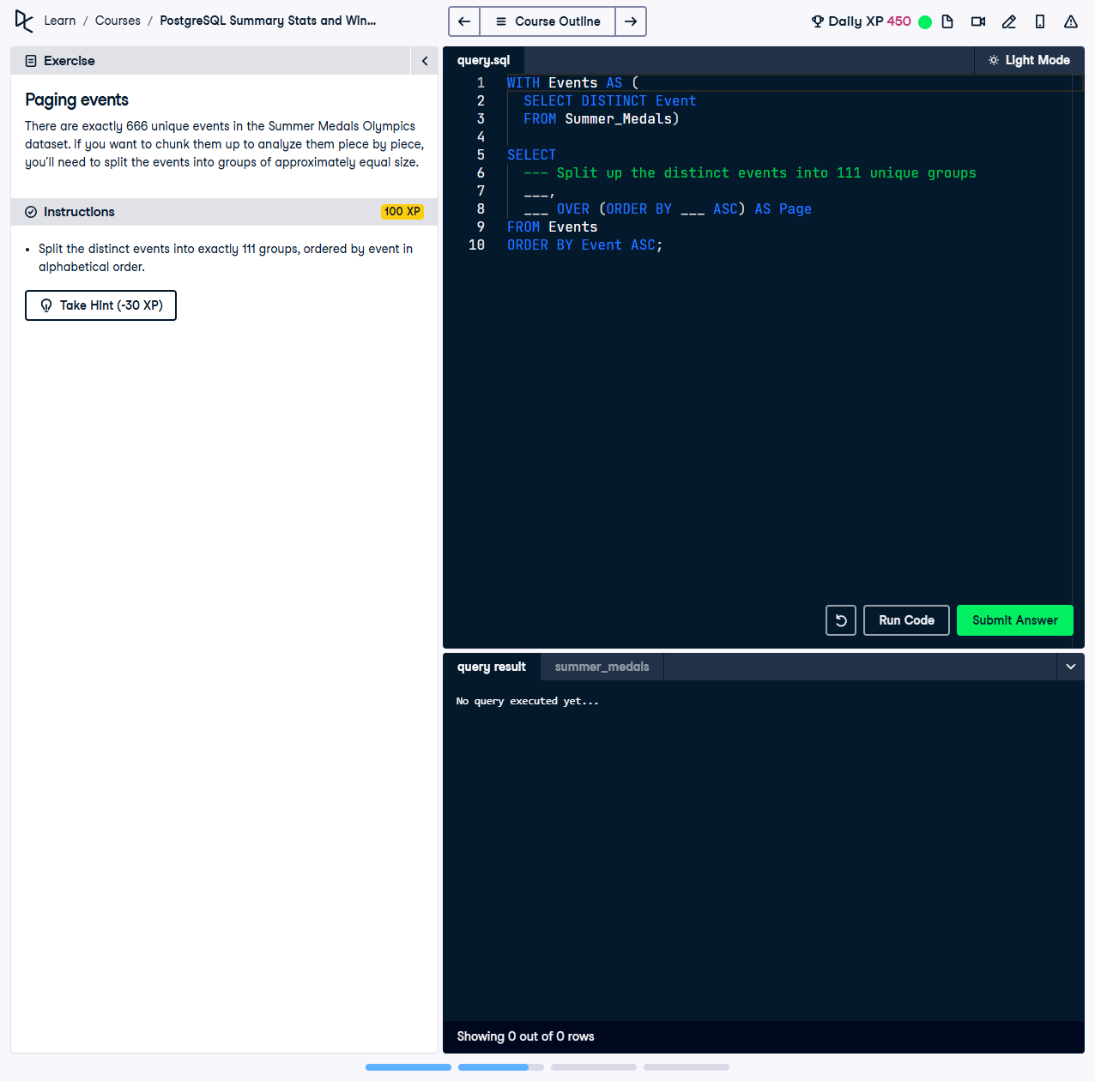

There are exactly 666 unique events in the Summer Medals Olympics dataset. If you want to chunk them up to analyze them piece by piece, you’ll need to split the events into groups of approximately equal size.

This exercise involves using a Common Table Expression (CTE) and the `NTILE` function to divide the distinct events into 111 groups, ensuring each group contains approximately an equal number of events. Events are grouped alphabetically.

## Correct Answer

WITH Events AS (  
 SELECT DISTINCT  
 Event  
 FROM Summer_Medals  
)  
SELECT  
 Event,  
 NTILE(111) OVER (ORDER BY Event ASC) AS Page  
FROM Events  
ORDER BY Event ASC;

Explanation of the query:

1. `WITH Events AS (...)`: This CTE retrieves distinct events from the dataset, ensuring no duplicates using `SELECT DISTINCT Event`.

2. `NTILE(111) OVER (ORDER BY Event ASC) AS Page`: The `NTILE(111)` function divides the events into 111 approximately equal-sized groups, ordered alphabetically by event.

3. `ORDER BY Event ASC`: Ensures the final output is sorted alphabetically by event name, allowing clear organization of grouped events.